
Date
June 6, 2002
Group
Click n’ Mortars

Internet Supply Chain Management

Project Summary

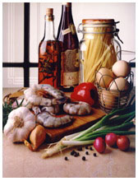

The World Food ExtraNet

Business Problem and Opportunity Overview

The speed and availability of real-time, global information has begun to impact all aspects of day-to-day life and business. To keep an edge and thrive in these dynamic times a new approach to business is required to take advantage of the speed of information.
In the food industry, however, many industry players still have not used technology to gain a strong competitive advantage; indeed, many still purchase their supplies and products by phoning in orders that are transcribed by hand. Moreover, products in the food industry are variable and catalogues alone are often not useful. Yet, the market is demanding faster response, higher quality, and lower costs.
The Click n’ Mortar team has identified several problems that currently plague the food industry:
- Slow cycle time
- Low efficiency and effectiveness in the supply chain
- Data inaccuracies and redundancies in database systems.

To solve these problems, our team has embraced the Internet as a strategic priority and believes that the full leverage of the technology is essential for enhancing the efficiency and effectiveness of the supply chain.

Specifically, a B2B exchange using available Web development technologies to facilitate communication between buyers and suppliers is appropriate for the food industry. An extranet system would facilitate contact and interaction between the exchange, registered suppliers, and registered buyers/customers. We call this system, The World Food ExtraNet.

Value Proposition and Cost Benefit Analysis

The World Food ExtraNet has a strong value proposition and would offer numerous opportunities for both the customer and supplier. The customer would benefit from quicker cycle times, convenience, lower prices (if purchasing in large volumes), 24x7 availability, enhanced product information with pictures and descriptions, data security, and the ability to track order status and reduce inventory. The supplier would also profit from a quicker cycle time, reduction of inventory and, at the same time, be able to access a wider global market and minimize operational costs. Other intangible benefits include a decrease in data redundancy and an increase in data integrity. There will also be an increase in process flow, no duplication of effort, and easier access to all data.

In addition to this qualitative analysis, the following chart quantitatively illustrates the costs that the project will incur as well as the future, tangible benefits once the project is completed.

Project Features

The World Food ExtraNet is robust, scalable, and secure. Its underlying technology consists of XML and message-based middleware (i.e., MSMQ), enabling suppliers to process orders submitted by customers and customers to purchase products posted by suppliers. Accordingly, The World Food ExtraNet offers unique features for the customer and supplier. After the customer logs in, she can search products using a simple search function or by browsing through categories, collect items in a shopping cart, update personal/company information, and track order status. Upon check out, credit card information is verified using a secure e-commerce. The supplier, on the other hand, can, after logging in, manually update product information, amount, availability, and price. In addition, after receiving a customer’s order, the supplier can access a database with the details of the order and track the status of the order online. Finally, employees of The World Food Extranet can log in to the system to update their own contact information, learn about training opportunities, or search for open positions within the company.

Project Scope

To keep The World Food ExtraNet project manageable within the time allotted, the Click n’ Mortar team offers the following project scope. The World Food ExtraNet will provide user information, user authentication, order placement, credit card validation, forward order capability, order status tracking, and the ability for suppliers to offer discount products.

Overall, The World Food ExtraNet is a next generation tool for the food industry. It provides a centralized environment for providing secure information and business transactions as well as quality product and supply and demand information. Ultimately, our team anticipates that with The World Food ExtraNet, players in the food industry will be able to gain a major competitive advantage.

Project Team and Roles

Joe Yiwei Zhou | As project leader, Joe was responsible for directing and coordinating the entire project team. He helped facilitate formal and informal decision making in order to achieve the agreed goals and objectives of our project. This process involved a high degree of interaction and led to the formulation of our strategies. He also helped to define the "customer's needs", the cost/benefits of our project, and the security analysis.
Sandy Lee | As Web site architect, Sandy was responsible for the design and structure of The World Food ExtraNet. Her proficiency in Web design, HTML, XML, and ASP as well as her commanding knowledge of tools such as Homesite enabled her to build the front-end that would hide the inner programming logic of The World Food ExtraNet. She created the graphics and color scheme for the site and helped with the content. She also helped write and manage the ASP code.
Natalie Teruya | As programmer analyst, Natalie was responsible for developing the process diagram that formed the foundation for the programming logic used in The World Food ExtraNet. Natalie’s deep knowledge of programming techniques made the proposed features of the project possible. She developed a VB application/DLL file to respond to the credit results received from the queue. She also developed the following functionalities:  - ASP code that builds xml to send to the credit authorization queue  - ASP code that retrieves a message from a queue and extracts needed information from the xml message  - ASP code that updates the database for the credit authorization queue results  - VB code that would act as a listener for the receiving queue (this feature would be functional if we had access to the server that contains the queue)
Jason Kemper | As the documentation specialist, Jason was primarily responsible for translating the ideas and notes of the team members into a narrative format for our stakeholders. He created the project abstract as well as the project summary deliverables. He edited documents produced by the other team members and coordinated these documents. He also researched the food supply industry and wrote the content for The World Food ExtraNet site.
Jin Sung Kong | As a system analyst, Jin contributed to creating the process diagram. He also performed a security analysis of The World Food ExtraNet and recommended policies and procedures for the site. Jin also developed diagrams to illustrate the complex security infrastructure.
Krissada Wimonchayanurak  And  Thamaraj Udomwongyont | As our e-commerce specialists, Krissada and Thamaraj were responsible for designing and developing the ASP logic for the shopping cart for The World Food ExtraNet. Their grasp of ASP and SQL technologies also enabled them to integrate the database with The World Food ExtraNet site.

System Solution Architectural Overview

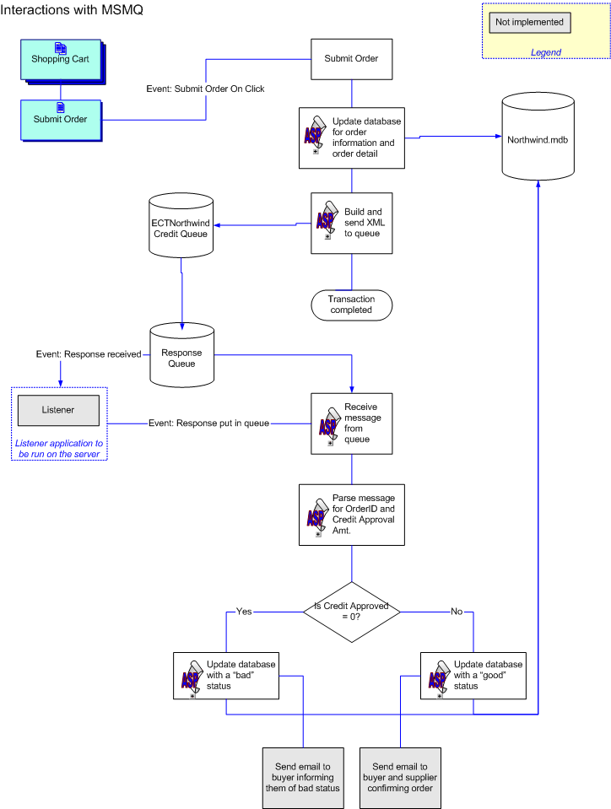

As the above diagram shows, The World Food ExtraNet utilizes MSMQ to send requests to and receive responses from the Credit Authorization application.

- Sending a request

When the user decides to check out and before the order is completed, the user is sent through a verification process. Upon final verification of the order and billing information, the user will hit the “Submit Order” button. This action triggers two steps: (1) an update of the database for the order and order details and (2) the building and sending of the XML string that makes up the credit authorization request to the MSMQ queue. During step 2, a response queue is also specified and relays to the credit authorization application the location of the queue that will be checked for authorization responses. Once the message has successfully been sent to the queue, the transaction is considered complete. At this point, the order’s credit status is “pending”. The user is told that an order confirmation will be received within 24 hours.

- Receiving a response

In the “live” version of The World Food ExtraNet, a “listener” application would be implemented. The purpose of this application would be to trigger an event that corresponds to a new message being places on the response queue. (This application would have to be running on a machine that has proper access rights to the response queue. Therefore, it was not implemented for this project.) The listener would load another application (for the project, this is implemented using ASP code) when a new message, an authorization response, was put on the queue. This application retrieves the message from the queue and parses the XML response.

If the appropriate amount of credit is approved, the application will update the database, giving the order a credit status of “good”. The confirmation will then be emailed to the user and the order is then forwarded on to the appropriate suppliers. (The email portion is also not implemented for this project.) If credit is rejected, the database will be updated, giving the order a credit status of “bad”. A cancellation email would be sent to the user and no email would be forwarded to the suppliers.

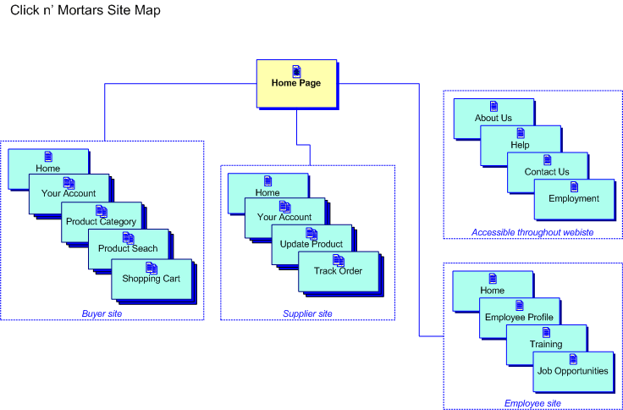

The above image is a high-level visual representation of the structure of The World Food ExtraNet. The site is divided into three major sections, each catering to a specific end user: a buyer, supplier, or employee. There are also pages in the site that are accessible by any user.

Security Architecture

This section provides information on security related issues and gives an overview of the risks and countermeasures to consider when implementing The World Food ExtraNet. The objective of The World Food ExtraNet security architecture is to provide the conceptual design of the network security infrastructure, related security mechanisms, and related security policies and procedures.
Within organizations, the expanded uses of connected computers to store, process, and share mission critical data over the public Internet has heightened the need for network security. Corporate networks in general and The World Food ExtraNet specifically depend on the accessibility of their sensitive data from many different places, outside as well as inside the organization. This dependence requires a careful management of the technologies available to secure the data as well as specific aspects of the storage and communication processes.

For the purposes of The World Food ExtraNet, it is helpful to first identify the major security threats that are currently faced. These threats can be categorized in two groups: (1) general threats and (2) threats unique to our system:

The general threats are as follows:

- No firewalls since we are using Middleware
- Poorly configured and constantly interrupted Internet systems
- Basic security problems with communication protocols from ISP to Internet
- Basic security problems with service programs (WWW. FTP, Telnet, etc.)

The unique security challenges and considerations for our system are:

- Shared endpoint security – with an extranet, security becomes a joint responsibility of the organizations at the endpoints that link a group of intranets or users
- Unmanaged heterogeneity- an extranet involves a population of local and remote users where it is virtually impossible to manage the types of technical heterogeneity used to access the extranet
- Cross-pollination – electronic joining of organizations increases the risk of cross-pollination and unwanted transfer of competitive information
- User anxiety – extranet security must be more extreme and apparent; administrators must always be convincing anxious users that a site is secure

A systems security is only as good as its security program and policies. In light of the aforementioned threats and concerns, we recommend the following high level policies for The World Food ExtraNet system.

A secure e-commerce infrastructure for conducting business transactions between buyers/customers and suppliers include:

- VPN protocol tunneling: Since many companies still use Windows 9.X platforms, we recommend PPTP to support both Windows 9.X platforms and Windows 2000 and XP.
- Secure authentication with passwords (already implemented)
- Interoperable security and certificate authorities
- IPv6 integrated with IPSec
- Content assurance and non-repudiation that guarantees transmissions have not been altered between sender and receiver
- Source validation to verify message source for legitimate processing
- Cross-application consistency to enable security software to be installed for a variety of applications without restricting transaction, communication, or processing activity.
- PKI (Private Key Infrastructure)
- Hostile code protection via sandboxing (i.e., installing access controls)
- Packet filtering. By using routers and checking IP address, we can effectively minimize access to our system. Two routers can be used: one connecting the Internet gateway to the Internet server and another connected internally between the Internet server and Intranet. This is illustrated with the following diagram.

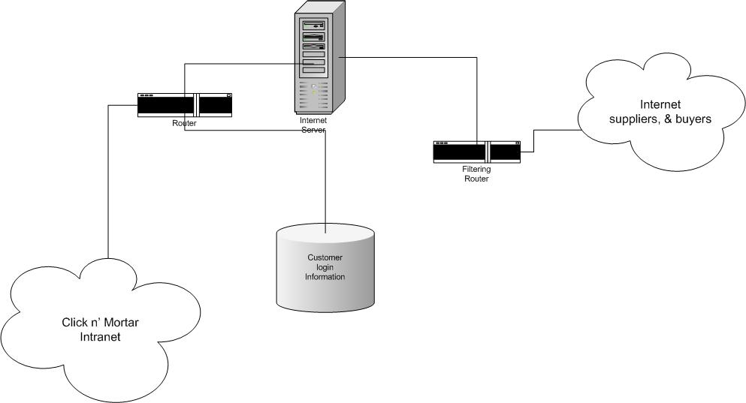

The following diagram illustrates the use of the VPN for security for The World Food ExtraNet.

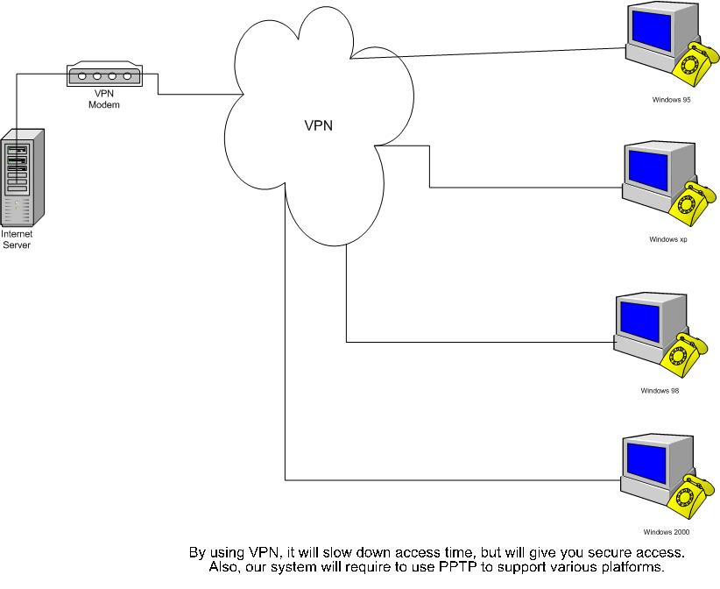

In terms of an access policy, physical access to IT hardware and infrastructure is limited to IT personnel with correct access levels. Each area that contains protected hardware should be secured by some kind of authentication device. Each user that wishes to gain access to the area will have to present identification. An authentication process limits users’ access to the system. Users are assigned access rights based upon their identity as a buyer, supplier, or employee. Users will be authenticated on the extranet through the use of a password. The IT department assigns passwords, which are case-sensitive and may contain digits and letters.

Although this security document is subject to revision and expansion, this section provides the starting point for achieving a secure environment for the World Food ExtraNet.

